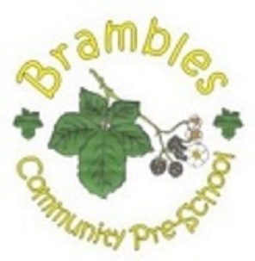
Brambles Lending Library

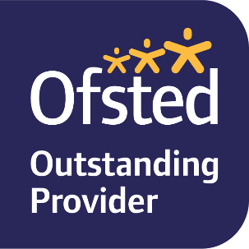
We offer a book lending library daily for all children. When your child brings their bookbag they have the opportunity to choose a book to take home and then return next time they are in. Reading books aloud to children stimulates their imagination and expands their understanding of the world. It helps them develop language and listening skills and prepares them to understand the written word.

